**To establish connection with mysql**

1. Create new Website

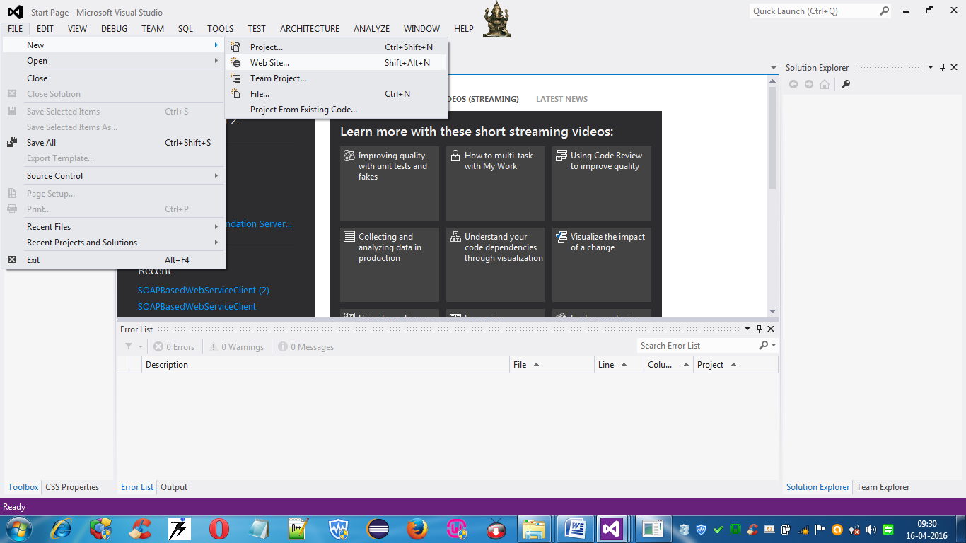

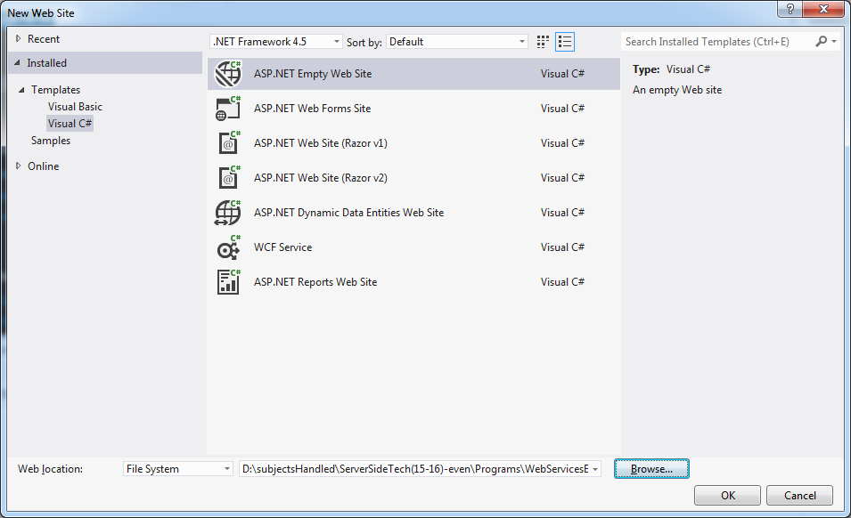

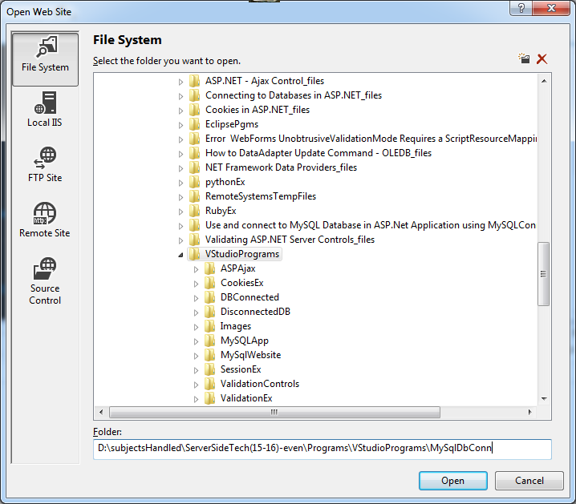

1. Rt.Click the project -> Add Reference

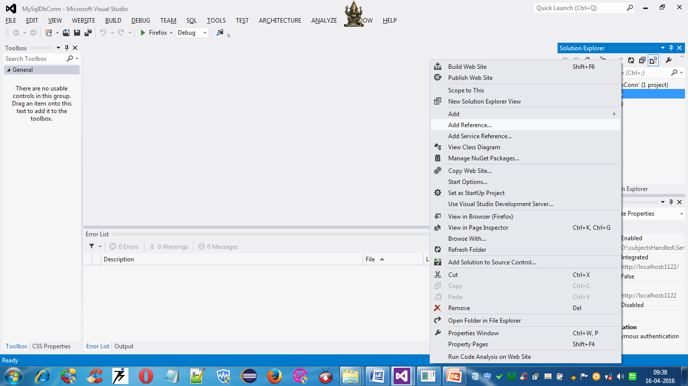

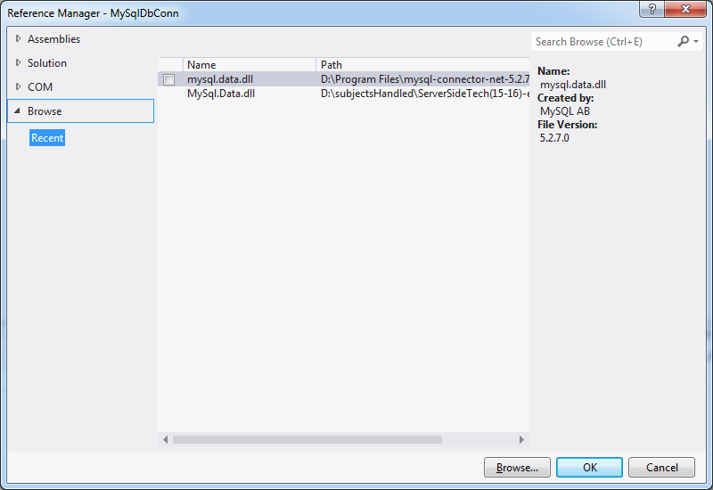

Click Browse and select the location where **mysql.data.dll** is present

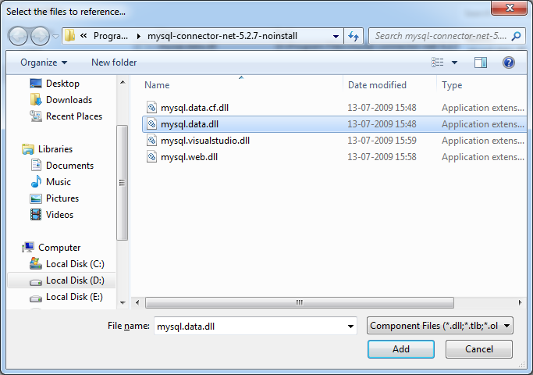

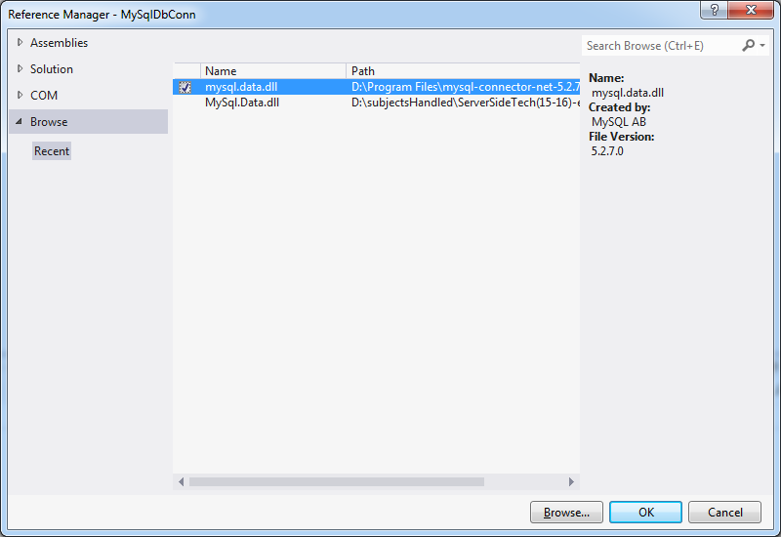

Now mysql.data.dll will be added

1. Rt.Click Project->New Item->Visual C#->Web Form

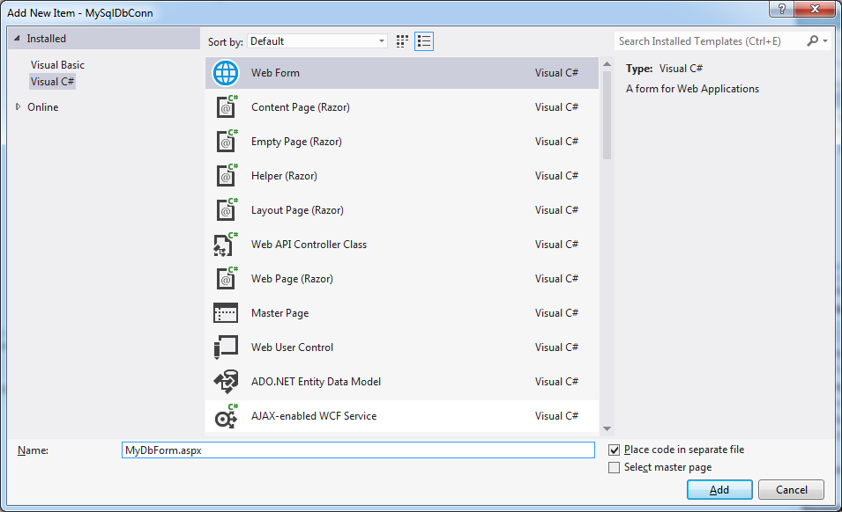

1. Include the following in the MyDbForm.aspx.cs

using MySql.Data.MySqlClient;

using System.Data;

1. **In MyDbForm.aspx**

<%@ Page Language="C#" AutoEventWireup="true" CodeFile="MyDbForm.aspx.cs" Inherits="MyDbForm" %>

<!DOCTYPE html>

<html xmlns="http://www.w3.org/1999/xhtml">

<head id="Head1" runat="server">

<title></title>

</head>

<body>

<form id="form1" runat="server">

<div>

</div>

<asp:Label ID="Label1" runat="server" style="z-index: 1; left: 131px; top: 152px; position: absolute" Text="EmployeeId"></asp:Label>

<asp:TextBox ID="TextBox1" runat="server" style="z-index: 1; left: 249px; top: 88px; position: absolute"></asp:TextBox>

<asp:TextBox ID="TextBox2" runat="server" style="z-index: 1; left: 249px; top: 153px; position: absolute"></asp:TextBox>

<asp:Label ID="Label2" runat="server" style="z-index: 1; left: 133px; top: 91px; position: absolute" Text="EmployeeName"></asp:Label>

<asp:Button ID="Button2" runat="server" style="z-index: 1; left: 207px; top: 242px; position: absolute; right: 567px" Text="Insert" OnClick="Button2_Click" />

<asp:Label ID="Label3" runat="server" style="z-index: 1; left: 406px; top: 89px; position: absolute; width: 108px"></asp:Label>

<asp:Button ID="Button3" runat="server" style="z-index: 1; left: 282px; top: 242px; position: absolute" Text="Update" OnClick="Button3_Click" />

<asp:Button ID="Button4" runat="server" style="z-index: 1; left: 369px; top: 244px; position: absolute" Text="Delete" OnClick="Button4_Click" />

<asp:GridView ID="GridView1" runat="server" style="z-index: 1; left: 579px; top: 68px; position: absolute; height: 133px; width: 187px; margin-top: 0px;">

</asp:GridView>

<asp:Button ID="Button1" runat="server" style="z-index: 1; left: 640px; top: 229px; position: absolute; height: 26px;" Text="Select" OnClick="Button1_Click" />

<p>

&nbsp;</p>

</form>

</body>

</html>

1. **In MyDbForm.aspx.cs**

using System;

using System.Collections.Generic;

using System.Linq;

using System.Web;

using System.Web.UI;

using System.Web.UI.WebControls;

using MySql.Data.MySqlClient;

using System.Data;

public partial class MyDbForm : System.Web.UI.Page

{

protected void Page_Load(object sender, EventArgs e)

{

}

protected void Button1_Click(object sender, EventArgs e)

{

MySqlConnection con = new MySqlConnection("server=localhost;database=msb;uid=root");//if password is there include pwd=password

MySqlCommand cmd = new MySqlCommand("SELECT * FROM student1");

cmd.Connection = con;

try

{

// Update dataset contents to database

con.Open();

MySqlDataReader dr = cmd.ExecuteReader();

DataTable dt = new DataTable();

dt.Load(dr);

GridView1.DataSource = dt;

GridView1.DataBind();

}

catch (MySqlException ex)

{

//MessageBox.Show(ex.Message);

}

finally

{

con.Close();

}

}

protected void Button2_Click(object sender, EventArgs e)

{

MySqlConnection con = new MySqlConnection("server=localhost;database=msb;uid=root");//if password is there include pwd=password

MySqlCommand cmd = new MySqlCommand("INSERT INTO student1 VALUES ('" + TextBox1.Text + "','" + TextBox2.Text + "')");

cmd.Connection = con;

try

{

// Update dataset contents to database

con.Open();

int result = cmd.ExecuteNonQuery();

if (result > 0)

Label3.Text = "Insert Success!";

else

Label3.Text = "Insert Failed!";

}

catch (MySqlException ex)

{

//MessageBox.Show(ex.Message);

}

finally

{

con.Close();

}

}

protected void Button3_Click(object sender, EventArgs e)

{

MySqlConnection con = new MySqlConnection("server=localhost;database=msb;uid=root");//if password is there include pwd=password

MySqlCommand cmd = new MySqlCommand("UPDATE student1 SET name='" + TextBox1.Text + "' WHERE rno=" + TextBox2.Text);

cmd.Connection = con;

try

{

// Update dataset contents to database

con.Open();

int result = cmd.ExecuteNonQuery();

if (result > 0)

Label3.Text = "Update Success!";

else

Label3.Text = "Update Failed!";

}

catch (MySqlException ex)

{

}

finally

{

con.Close();

}

}

protected void Button4_Click(object sender, EventArgs e)

{

MySqlConnection con = new MySqlConnection("server=localhost;database=msb;uid=root");//if password is there include pwd=password

MySqlCommand cmd = new MySqlCommand("Delete from student1 WHERE rno=" + TextBox2.Text);

cmd.Connection = con;

try

{

con.Open();

int result = cmd.ExecuteNonQuery();

if (result > 0)

Label3.Text = "Delete Success!";

else

Label3.Text = "Delete Failed!";

}

catch (MySqlException ex)

{

}

finally

{

con.Close();

}

}

}